USER MANUAL FOR THE APPLICATION BIOWAR AND DISEASE OUTBREAK IN INDIA

1. Go to the Url :

http://176.32.230.17/sriramtestdomain.com/word/

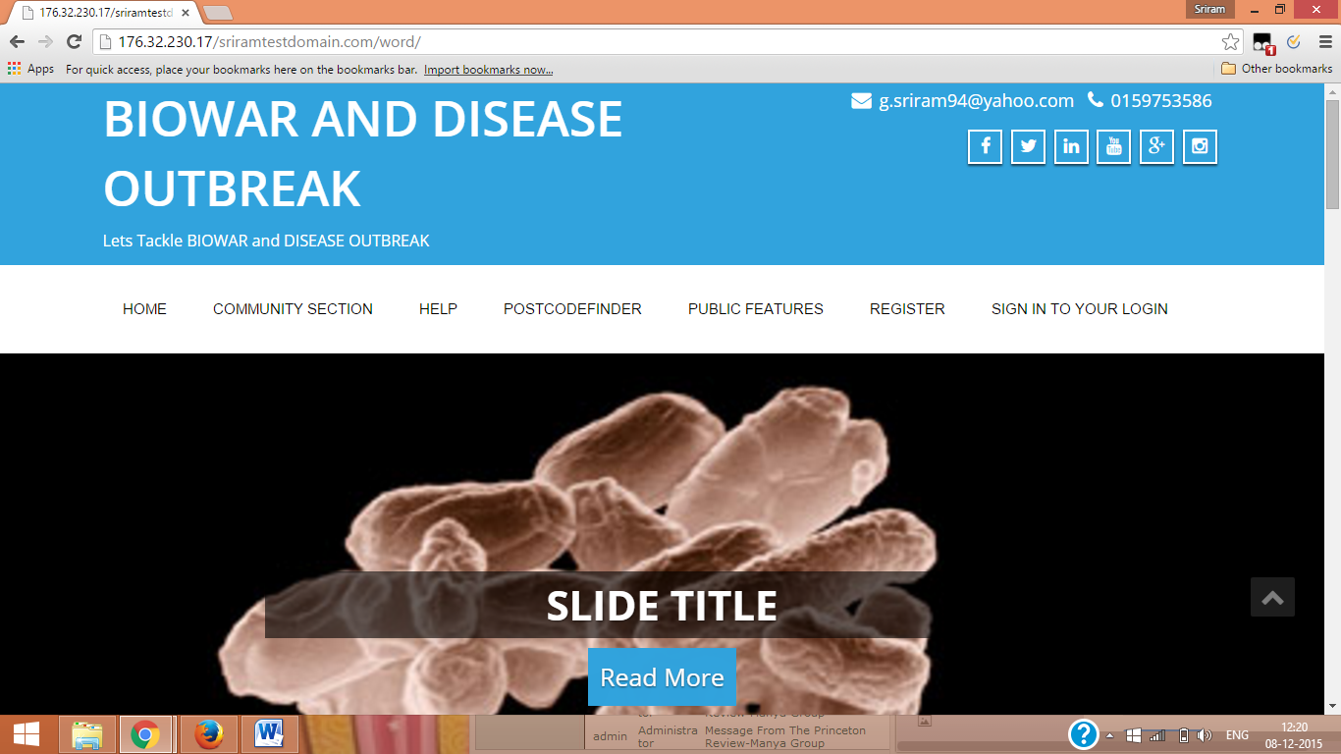

1. Register yourself as a Hospital. Each hospital is rendered a unique user name and password.

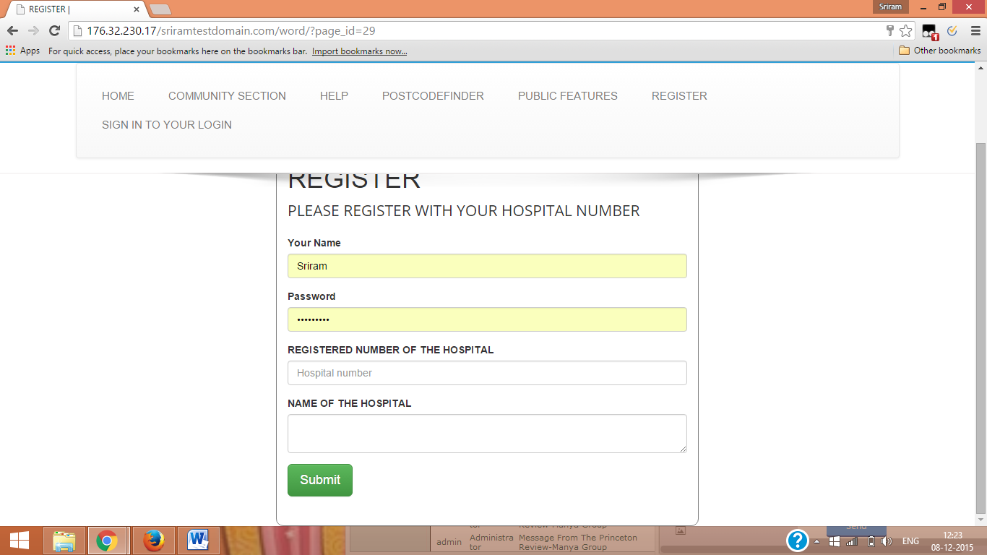

1. Once the registration is complete a unique password is generated which enables you to sign in

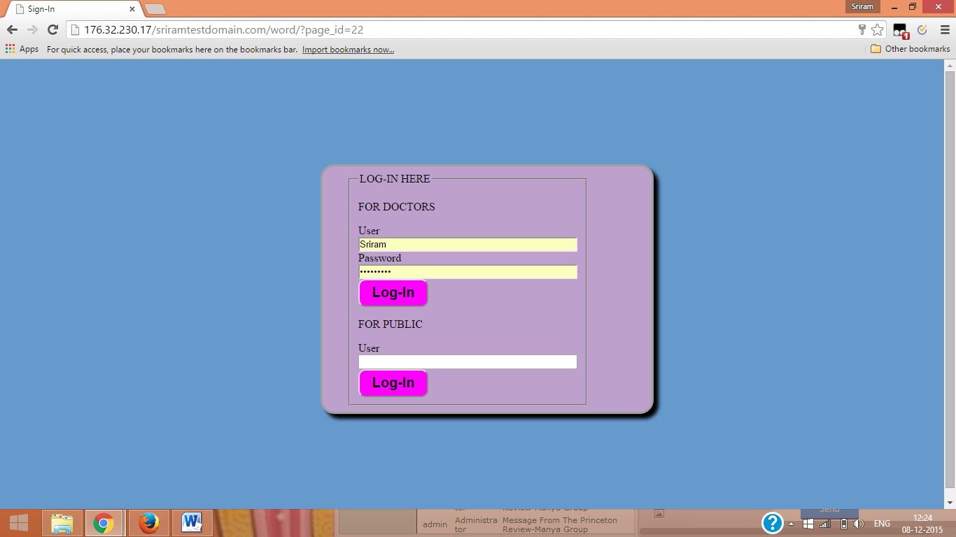

1. Once the doctor has signed in he has to fill a form to report a communicable disease.

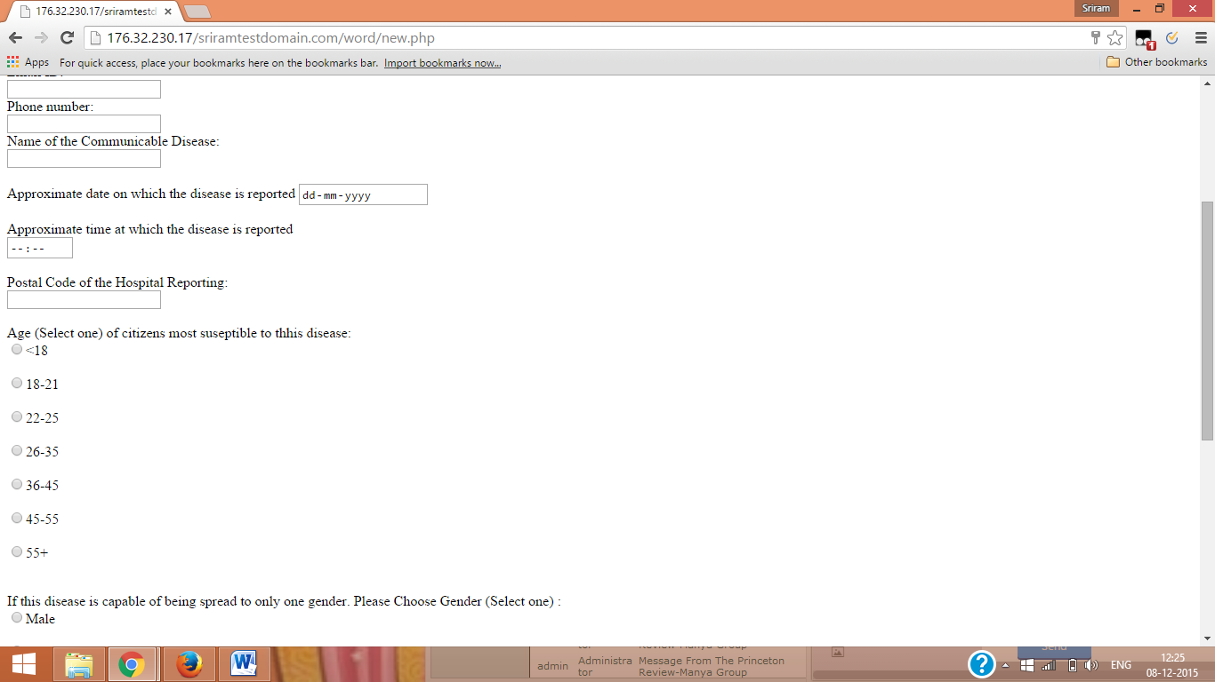

1. Once this is done a message of successful submission occurs in the screen

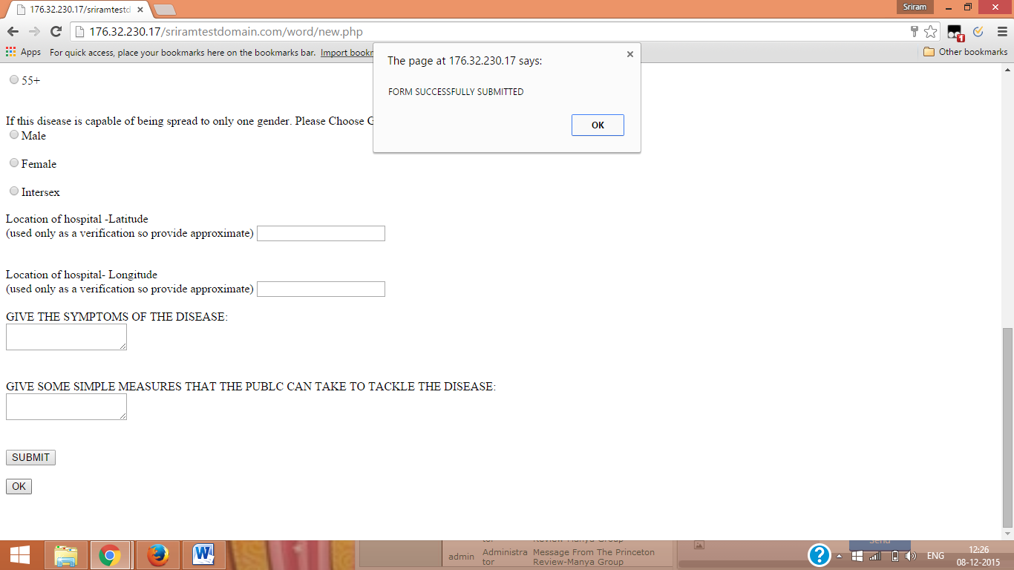

1. Once this is done we can view the details as a web map on the community section.

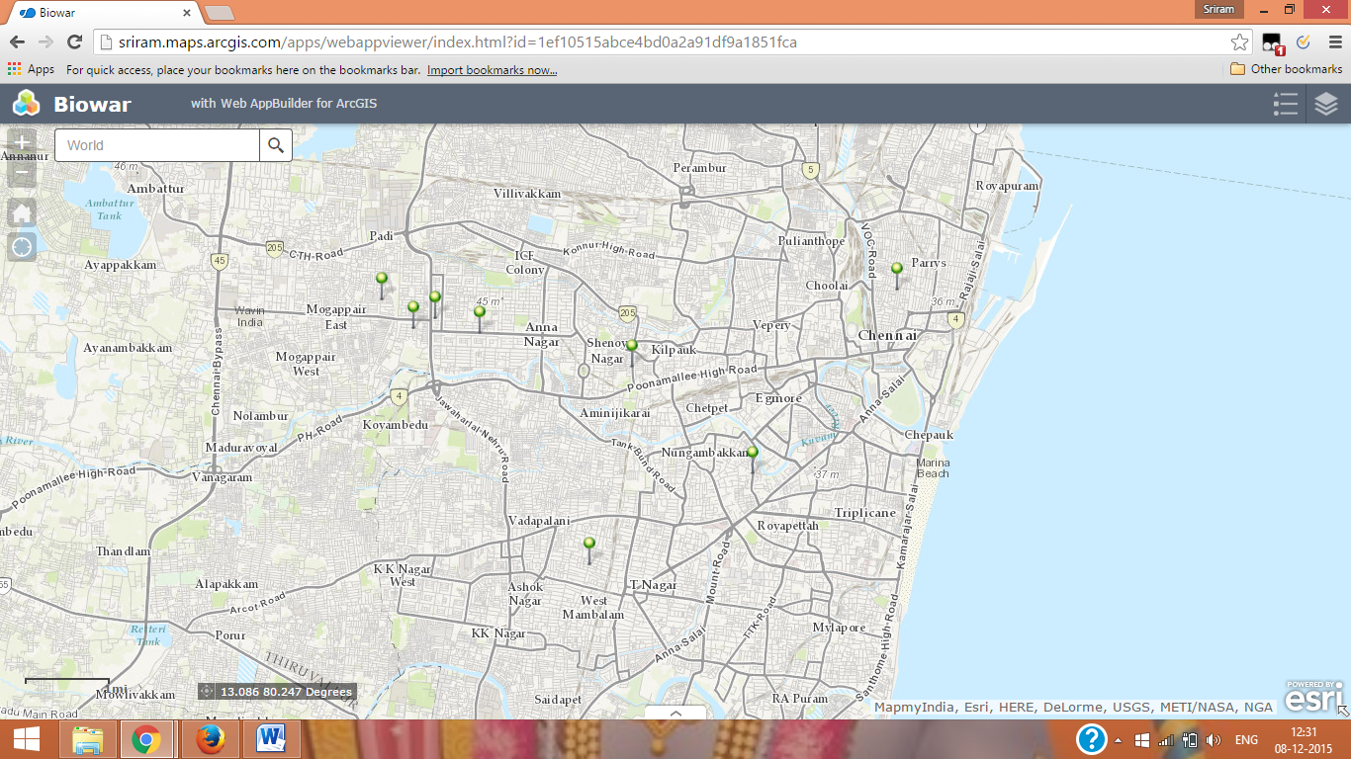

1. There are a number of special features which can be used for giving special effects to the spatial features. This can be accessed from the public features window . For example there is the Buffer tool which can be used to draw the buffers to identify the affected regions

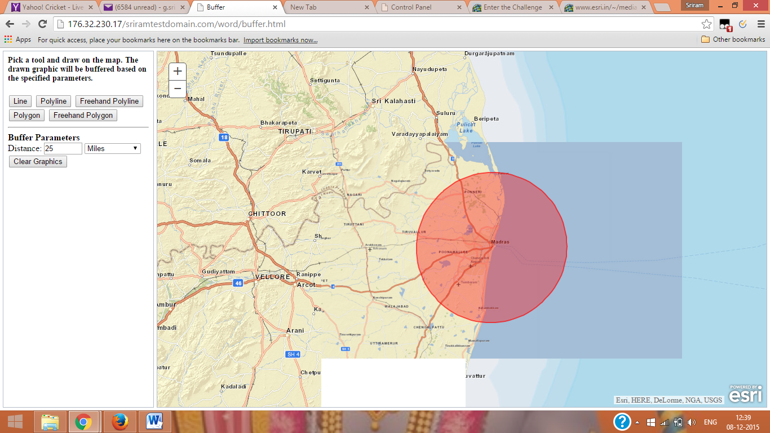

1. The community section can be accessed to add information that can be viewed by the public.

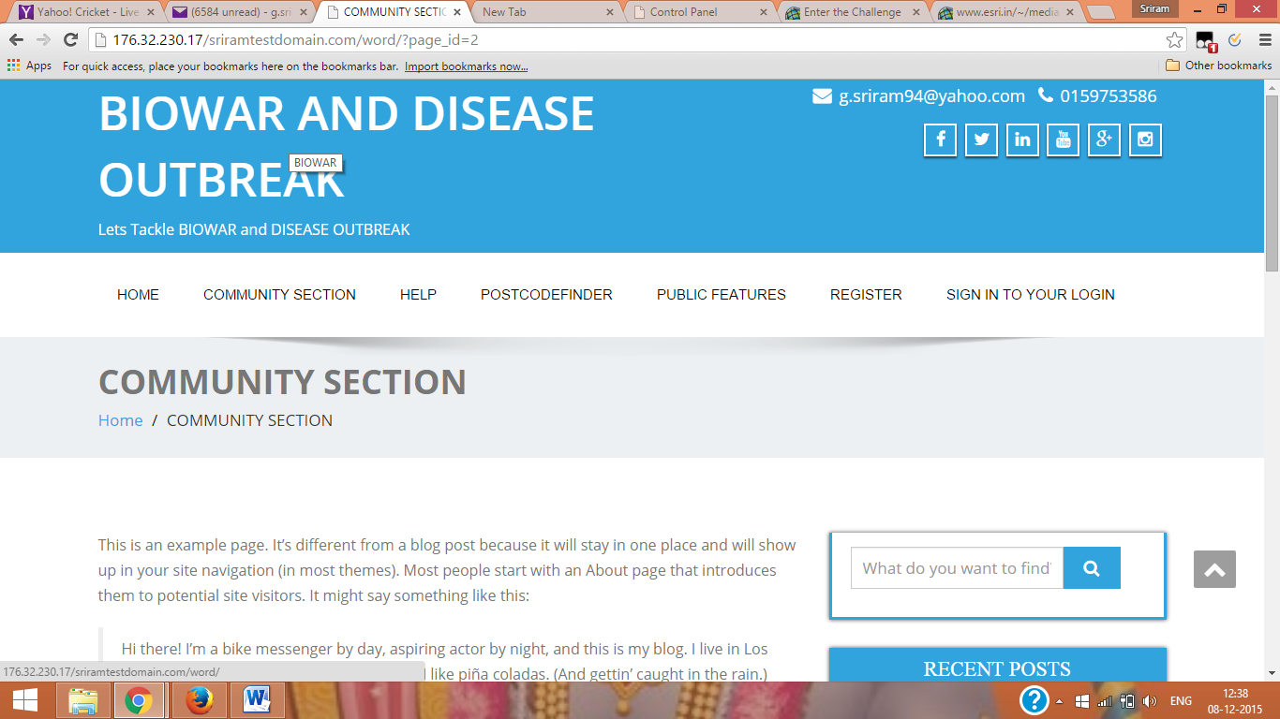

1. The public can give their user names and leave messages and questions to the doctors.

10)There is a vibrant user community developed and the user gets notifications in the home page.

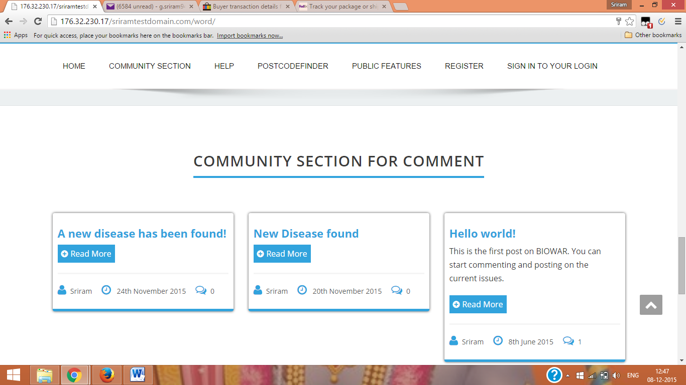

1. The postcodefinder tab automatically converts physical addresses to lat-long for the effective processing of the application.

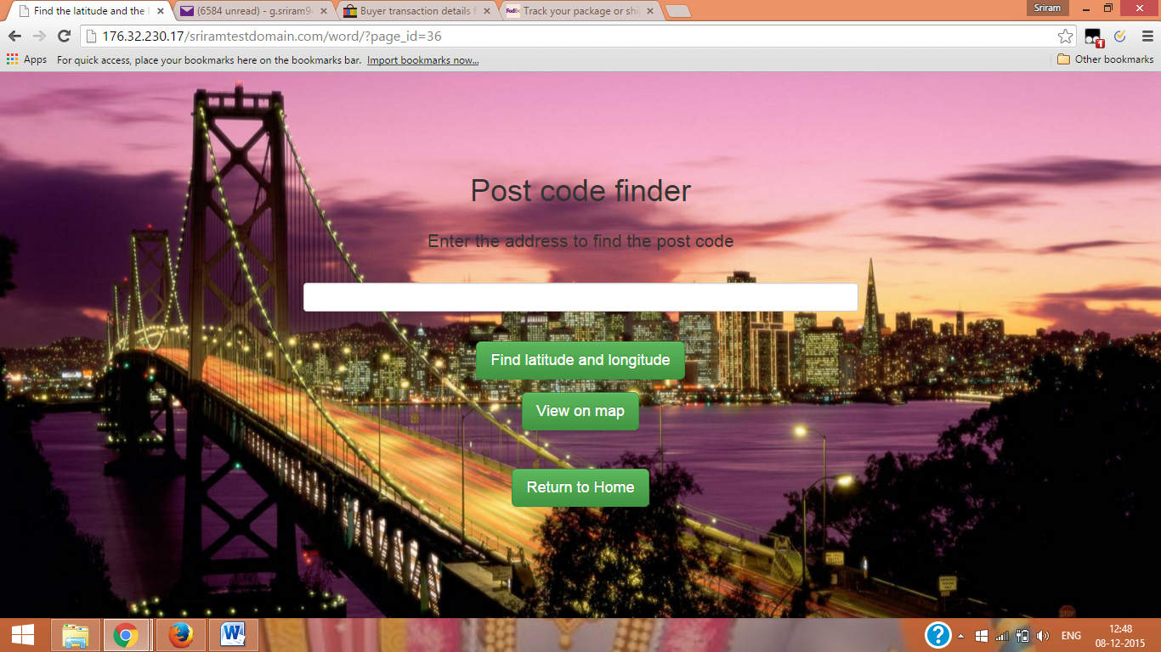

1. The application has direct capabilities to include and send information to the social media like facebook , Instagram, twitter etc. These features are available right at the top of the application.

